Attention Female Engineers:
Lunch Study Break
Come join your fellow engineers for some food and fun.
Free Lunch (Not Pizza)
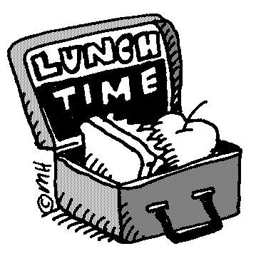
May 3, 2011
1:10-1:50
Duck 351
Come out and enjoy good food, games and conversation.
All are welcome!

Sponsored by:

